GREATER WHITSUNDAYS ECONOMIC DEVELOPMENT ROAD MAP

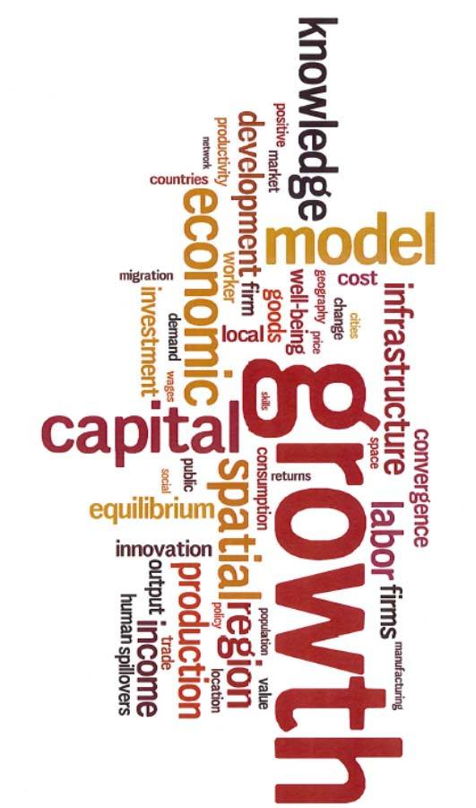

:

What is this all about?
As part of Australian Government Commitment toward long-term regional development, the Department of Infrastructure, Transport, regional Development and Communications is contracting Regional Development Australia Mackay Isaac Whitsunday (RDA MIW) to work with regional stakeholder to create a Greater Whitsunday Reginal Development Strategy and Road Map. We seek your involvement as a valued regional stakeholder to take part in the development of the Strategy and Road Map.

Who Is Involved?
RDA MIW has received support via a working group guiding the development of the strategy and Road Map. Working group members comprise representatives from Greater Whitsunday Councils of Mayors, Whitsunday Regional Council, Mackay Regional Council, Isaac Regional Council, Greater Whitsunday Alliance, Department of State Development Infrastructure, Local Government and Planning and Department of Premier and Cabinet.

Why Should I Be Involved?
If you have an interest in being part of a process with other regional stakeholders that identifies regional development priorities toward infrastructure aspirations, policy wants, and program needs this Strategy and Road Map process is for you.

How Will It Be Done?
- Two face to face workshops in Mackay
  - Workshop 1 sets the scene and works with stakeholders to set a regional vision, presents information and context toward economic priorities, and seeks workshop attendees’ responses toward the information and any challenges, opportunities potential projects and enablers/influencers, next steps, and the way forward.
  - Workshop 2 provides an update from workshop 1 and directly seeks stakeholder support and buy in to the key findings through a feedback opportunity. It is proposed a draft workshop 1 report to all workshop attendees will be provided allowing feedback that can then be considered and updated at workshop 2.

- Two virtual online workshops – for those not able to make it in person, online workshops will cover the same aspects as the face to face workshops.

What Has happened To Date?
- Funding to support develop of the strategy and road map has been secured.
- Service contractor to support RDA MIW and the Working Group has been contracted.

What Is Next?
- Promote the face to face and virtual workshops via this date claimer.
- Seek stakeholder interest and involvement and registration.
- Registered workshop attendees will be further contacted and provided information and details

When and How Do I Register?
- Registrations are required on or before Monday 5th July 2021.
- Contact Nic Willis on 0487 895 796 or email: projectmanager@rdamiw.org.au

Planned Program
Face To Face
- Workshop (1): Monday 12th July: 8.30am - 3.30pm

- Workshop (2): Thursday 19th August: 8.30am - 3.30pm

- Venue to be confirmed.

Virtual/Online – Via Microsoft Teams
- Workshop (1): Thursday 15th July: 9.30am - 1.00pm

- Workshop (2): Thursday 23rd August: 9.30am – 1.00pm

PROGRAM OUTCOMES

Come on board and support us to determine the following:
- Identify a clear and robust vision for the Greater Whitsundays region that builds on the existing strengths and identifies future opportunities to create a resilient regional economy, environment, and community.
- Identify key projects and programs that will provide local economic stimuli, job creation, services and productivity growth and improved living standards for business and community.
- Identify new opportunities for collaboration, alignment, and preparedness for regional economic diversity and transformational change.
- Support future infrastructure aspirations, policy change to support sustainable growth, direction for regional funding aligned to infrastructure and community development.

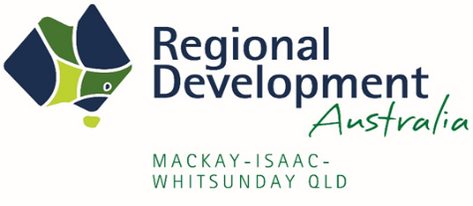
GET IN TOUCH > For questions on the workshop, or assistance with registration please contact Nic Willis on 0487 895 796 or email: projectmanager@rdamiw.org.au

